Awards

Year | Description | Links
2024 | iF Design Award 2024  Hotlink App: Self-Serve Mobile Application Winner  

2024 Talentbank Graduates' Choice Awards
- Top 1% of 25 Most Preferred Graduate Employers in Malaysia
- Ranked #1 in Telecommunications Category
- Ranked #5 in Technology Category


Maxis network site first in Malaysia to be certified with ISO 14001:2015 Environmental

Management Systems
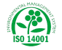

Mobile 360 Digital Nations Award
Excellence in Sustainability Video Award


2023 | MCMC Capacity Development Programme 2023  MCMC Chairman's Recognition Award for Top Participation in 2023  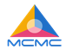
Putra Brand Awards 2023
- The People's Choice in Communications Network Category: GOLD for Maxis
- The People's Choice in Communications Network Category: SILVER for Hotlink
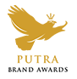
2023 Contact Centre Association of Malaysia (CCAM) 24th Annual Industry Excellence Awards
- Best In-house Inbound Contact Centre : Large (Above 100 Seats) : GOLD
- Best In-house Outbound Contact Centre (Telesales): GOLD
- Best Customer Experience Program in a Contact Centre: GOLD
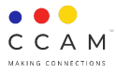

2023 Talentbank Graduates' Choice Awards
- Top 1% of 25 Most Preferred Graduate Employers in Malaysia
- Ranked #1 in Telecommunications Category
- Ranked #6 in Technology Category

GradMalaysia Malaysia's 100 Leading Graduate Employers 2023
Bronze for Best Rewards and Recognition Programme



GRADUAN Brand Awards 2023
2nd runner up in Telecommunications Category

2022 | Anugerah Syarikat Swasta Berprestasi Tinggi, Royal Malaysian Customs Department  Top 3 Highest Service Tax Contributor 2021, High-performing Private Company Category  
Maxis Business - A+M'S Agency of the Year (AOTY) 2022
- eCommerce Marketing Agency of the Year
- Gold in the eCommerce category
- Local Hero Award in the eCommerce category


Maxis Business - MARKies Awards 2022
- Silver: Most Effective Use - Integrated Media: XIXILI Intima
- Silver: Most Effective Use - Specific Audience: Fitness Concept
- Silver: Most Creative - Covid-19 Response: MR. DIY
- Bronze: Most Creative - Digital: MR.DIY

Contact Centre World Awards 2022
- Best Contact Centre in the Large Contact Centre Category under Customer Service Awards
- Best Sales Campaign under Strategic Awards
- Best Use of Self-Serve Technology under Technology Awards

 | Bursa Top 20: Who's The Most Charitable  - Giving in Action 2021: eKelas, festive charity, and network and flood relief efforts   | https://www.wikiimpact.com/bursatop20/2022/maxis/
 | LinkedIn Top Companies Malaysia 2022   | https://www.linkedin.com/pulse/top-companies-2022-15-best-workplaces-grow-your-career--2e/
2021 | Champion in Telecommunications Category and 7th Place Overall, Graduates' Choice Award 2021/2022
 | First runner up, Telecommunications Category, M100 Leading Graduate Employers Awards
Finalist in 2021 PWC Malaysia Building Trust Award

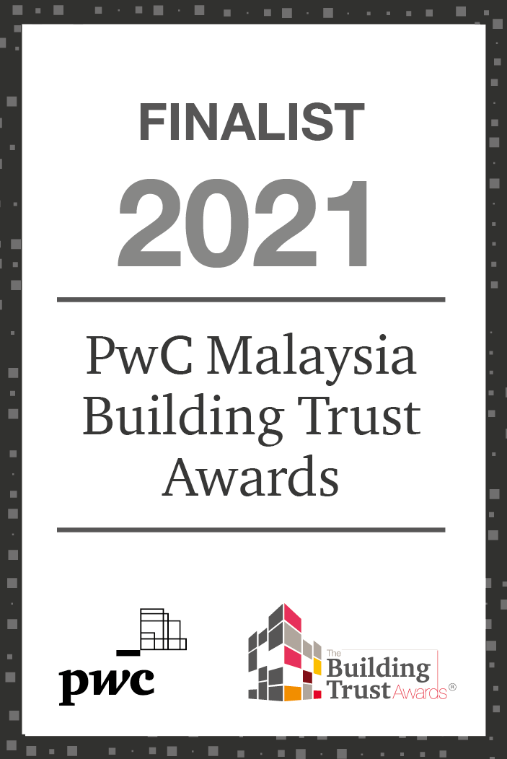
2020 | The Edge Billion Ringgit Club 2020  - Super Big Cap Companies - Above RM40 billion Market Capitalisation  - Highest Return on Equity over Three Years   | https://brc.theedgemalaysia.com/2020/
PC.com Best Product of the Year 2020
- Telco of the Year (TOTY)
- Best 4G Coverage
- Best Enterprise Telco

Asia eCommerce Awards 2020
- Gold: Best in eCommerce (Fashion & Apparel) - XIXILI Intima
- Gold: Best in eCommerce (Baby, Personal Care & Home Products) - Kuvings Malaysia
- Silver: Best in eCommerce (Baby, Personal Care & Home Products) - MR.DIY
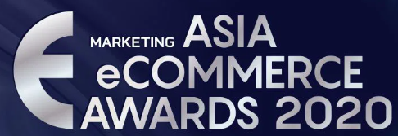
 | A+M 11th Agency of The Year (AOTY) and Markies Awards    - Gold: Specialist Agency of the Year  - Local Hero Award: Specialist Agency of the Year  - Silver: Effective Use of Digital - Kuvings Malaysia | https://awards.marketing-interactive.com/agency-of-the-year-my/
7th Annual ALB Malaysia Law Awards
Technology, Media & Telecommunications In-House Team of the Year
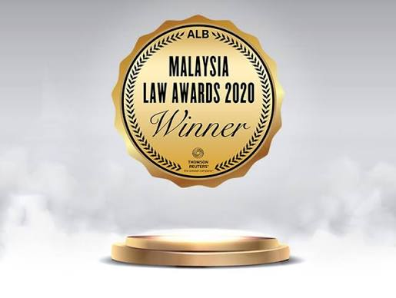
 | Speedtest Awards by Ookla 2020  Fastest Mobile Network (Malaysia) - Q1-Q2 2020  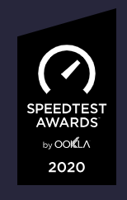 | https://www.speedtest.net/awards/malaysia/2020/?award_type=carrier&time_period=q1-q2
2019 | The Edge Billion Ringgit Club 2019  Highest Return on Equity for Three Years   | https://brc.theedgemarkets.com/2019/winners.php
 | Putra Brand Awards  Platinum in Communications & Network  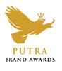 | https://aaaa.org.my/putrabrandawards/
 | Malaysia Effie Awards  - Brand of the Year  - Gold winner - Internet Services, Telco Products & Services  - Silver winner - Positive Change: Social Good – Brands   | https://www.malaysiaeffie.com/
Kancil Awards 
- Advertiser of the Year
- Innovation Kancil
- Culture Kancil
https://www.kancilawards.com/winners/year/2019

- Gold - Best use of cultural insights in brand experience & activation
https://www.kancilawards.com/winners/entry/2019/5768

- Silver - Best use of cultural insights in audio
https://www.kancilawards.com/winners/entry/2019/5676

- Silver - Best use of audio & voice technology
https://www.kancilawards.com/winners/entry/2019/5675

- Silver - Innovation in audio
https://www.kancilawards.com/winners/entry/2019/5678

- Silver - Kancil for good: film & branded content
https://www.kancilawards.com/winners/entry/2019/5643

- Silver - Best use of mobile & wearable platforms
https://www.kancilawards.com/winners/entry/2019/5733

- Silver - Digitally Enhanced Physical Experience
https://www.kancilawards.com/winners/entry/2019/5749

- Silver - Kancil for good: Audio
https://www.kancilawards.com/winners/entry/2019/5680

- Bronze - Sound design in film content
https://www.kancilawards.com/winners/entry/2019/5888

- Bronze - Best use of cultural insights in digital experiences
https://www.kancilawards.com/winners/entry/2019/5717

 | Malaysian e-Payments Excellence Awards (MEEA) 2019  Top FPX merchant (Corporate Sector) category   | https://paynet.my/press-release/2018/MEEA-2018-Press-Release.pdf
 | Dragons of Malaysia  GOLD DRAGON: Best Entertainment campaign  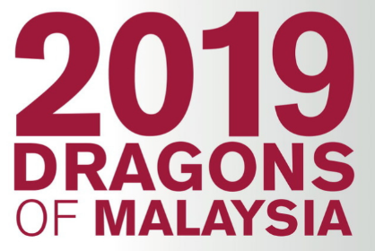 | https://marketingmagazine.com.my/dragons-of-msia-winners-2019/
 | Malaysian Media Awards  Bronze : Best Use of Social Media/Influencers | http://mma.mymsa.org/?p=shzqsawkk
 | Graduates' Choice Award 2019  - Top Five Most Attractive Employer Brands - 2nd Runner-Up  - Graduate's Choice Award for Telecommunication - Champion | https://www.graduateschoiceaward.com/
 | Star Rating Award 2018  Best Network Investment | https://www.mcmc.gov.my/en/media/press-releases/mcmc-meraikan-syarikat-telekomunikasi-cemerlang-pa
 | Malaysia Law Awards  Technology, Media and Telecommunications In-House Team of the Year   | https://www.legalbusinessonline.com/awards/malaysia-law-awards-2019
2018 | The Edge Billion Ringgit Club 2018  - Super Big Gap Companies: Above 40B Market Capitalisation  - Highest Return on Equity for Three Years   | https://brc.theedgemarkets.com/2018/winners.php
 | Putra Brand Awards  Gold in Communications & Network | https://aaaa.org.my/putrabrandawards/
 | Forbes Global 2000  - #1776 Global 2000 2018  - #464 World's Best Employer   | https://www.forbes.com/lists/worlds-best-employers/#tab:rank_search:maxis
FTSE4GOOD INDEX SERIES

 | HRM Asia  - Asia's Most Effective Workplaces  - Representing Malaysia  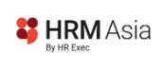 | https://hrmasia.com/asias-most-effective-workspaces-revealed/
2017 | Global Effie Effectiveness Index  #7 Most Effective Global Brand  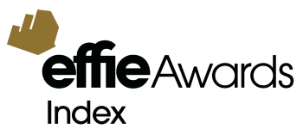 | https://www.effieindex.com/ranking/?rt=5
WARC 100
World's top brand in Telco category from Asia

 | Forbes Global 2000  #1596   | https://topforeignstocks.com/2018/04/21/forbes-global-2000-companies-list-year-2017-edition/
Asian Human Capital Award
Winner
The Edge Billion Ringgit Club
- Gold for Highest Return on Equity Over Three Years (2014 - 2016) under Super Big Cap Companies category
- YouTube Malaysia Ads Awards
- YouTube Malaysia Ad of the Year
- Top Ad in Tech & Telco

 | Effie Awards  - Brand of the Year  - Gold in Efforts for Good  - Bronze in Engaged Community  - Bronze in Internet Services, Telco Products & Services  - Bronze in Media Idea   | https://archive.marketingmagazine.com.my/maxis-and-mudah-my-shine-at-effie-malaysia-2017/
 | Malaysian Media Award  - Grand Prix  - Advertiser of the Year  - Gold in Video  - Gold in Digital  - Gold in Out of Home Media/POS media  - Gold in Small Budget  - Gold in Campaign That Drives Commerce  - Silver in Best Use Digital Performance Strategy  - Silver in Creative Use of Data  - Silver in Best Integrated Media Campaign | http://mma.mymsa.org/?cat=65&year=2017
 | Agency-Marketer Partnership Award  Gold  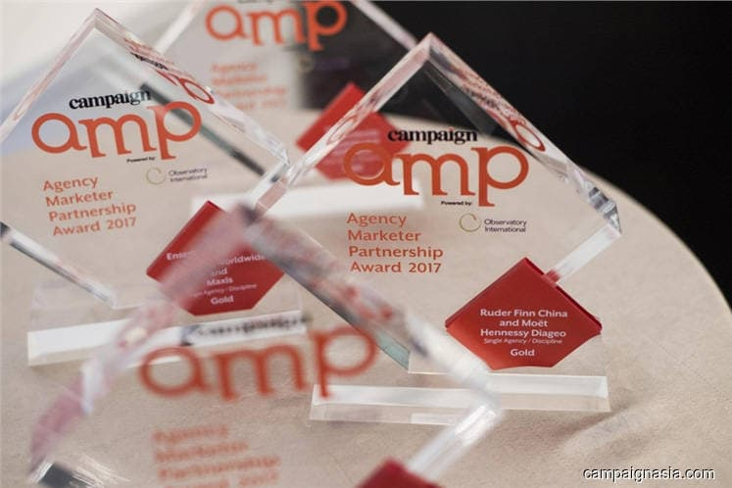 | https://www.thestar.com.my/business/business-news/2017/09/16/ensemble-maxis-win-gold-award/
 | Putra Brand Awards  Gold in Communications & Network | https://aaaa.org.my/putra-brands-awards-2017-results/
 | MCMC's Star Rating Award  - Best Cellular Service Provider  - Best Network Investment  - Best in Compliance to Communications and Multimedia Act 1998  - Best in CSR | https://www.mcmc.gov.my/en/home
 | HWM + HardwareZone.com.my Tech Awards  Best Telco | https://techawards.hardwarezone.com.my/
 | Lowyat 2017 Community Choice Awards  - Best Telco of 2017  - Best LTE Network in Malaysia   | https://www.lowyat.net/2017/151469/lowyat-net-2017-community-choice-awards-winners/
2016 | The Edge Billion Ringgit Club 2016  - Highest Return on Equity Over Three Years for Super Big Cap Companies  - (Companies with more than RM40 Billion Market Capitalization) Category  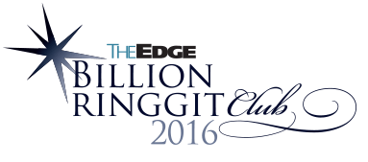
Putra Brand Awards 2016
GOLD in Communication Networks
Telecom Asia's 19th Annual Awards
- Best Emerging Market Operator
- Telecom CEO of the Year
Effie Awards (Malaysia) - November
- Brand of the Year
- Gold in Media Idea
- Gold in Engaged Community
- Silver in Brand Experience
- Silver in Internet Services, Telco Products, and Services
- Silver in Efforts for Goods-Brands (two awards)
- Bronze in Brand Experience
- Bronze in Internet Services, Telco Products, and Services
- Bronze in Corporate Reputation
Effie Awards (Asia Pacific) - April
- Silver for Maxis New Network (under Asia Pacific Brands Category)
- Silver for Maxis New Network (under IT/Telco Category)
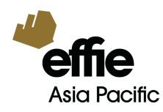
Lowyat 2016 Community Choice Awards - December
Best LTE network
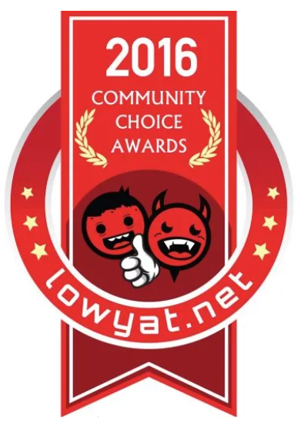

YouTube Malaysia Ads Awards - December
- Top Ad of the Year 2016
- Best Long Form Ad
- Top Ad in Tech and Telco

2015 | Putra Brand Awards 2015  21 August 2015  The People's Choice - GOLD Communications Network
2015 Frost & Sullivan Malaysia Excellence Awards
14 April 2015
- Information & Communication Technologies - Malaysia Mobile Data Service Provider of the Year
- Excellence in Customer Experience - Telecommunications Industry Malaysia - In Store
- Excellence in Customer Experience - Telecommunications Industry Malaysia - Contact Center
YouTube Ads Leaderboard
15 June 2015
Hotlink
Malaysia Winner

Computerworld Malaysia Customer Care Awards
11 June 2015
Best Customer Care for Telecommunication Services (based on popular votes by the readers of Computerworld)
2014 | Lowyat.Net 2014 Community Choice Awards  24 December 2014  - The best local telecommunications provider of 2014  - The best new postpaid plan in 2014 - MaxisONE Plan  - The best prepaid plan in 2014 - #Hotlink  - Best LTE Network in Malaysia  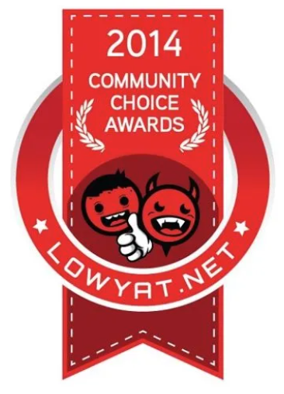
15th National Customer Experience Industry Award 2014
08 November 2014
Individual Awards - Team Leader

- Best Contact Centre TL - Inbound (above 100 seats)
- Best Contact Centre TL - Outbound (under 100 seats)
- Best Contact Centre TL - WF/ QA (above 100 seats)
Malaysia's 100 Leading Graduate Employers Awards 2014
07 November 2014
The most popular graduate employer in Telecommunications 2014 - Winner
8th Annual Computerworld's Customer Care Awards
12 June 2014
Telecommunications category - Winner
Putra Brand Awards 2014
25 April 2014
The People's Choice
GOLD - Communication Networks

PC.com 13th Readers' Choice Awards 2013
27 February 2014
Best Postpaid Service Provider


2013 | GradMalaysia Graduate Recruitment Awards 2013  07 November 2013  Best Management Trainee / Graduate Programme  
Malaysia's 100 Leading Graduate Employers Awards 2013
07 November 2013
Best Graduate Employer (Telecommunications)
Malaysia’s Top 100 Leading Graduate Employers


14th Malaysia CRM & Contact Centre Industry Award 2013
12 October 2013
Best of the Best Contact Centre in Malaysia (In-house Category)
Corporate awards
1st Place
- Best In-House Outbound Contact Centre (under 100 seats)
- CRM Programme Implementation Contact Centre
- Process Excellence Contact Centre
- Social Media Programme Contact Centre
- Technology Innovation Contact Centre

Computerworld Malaysia Customer Care Awards 2013
06 June 2013
- Telecommunication Services (Maxis)
- Cloud (Maxis)

Reader's Digest TRUSTED BRAND 2013
28 May 2013
- PLATINUM
- Phone & Broadband Service

Putra Brand Awards 2013
26 April 2013
- The People's Choice
Putra Brand Icon
- The People's Choice
GOLD - Communication Networks

CNET Asia's Readers Choice 2012/2013 - Best Telco (Malaysia)

31 January 2013

